|  |
| --- |
| Deep Space Explore |
| ASTEROID PROSPECTOR |
| It is a Game for to travel across the solar system from asteroid to asteroid. The strategy is to decide which asteroid to visit and mine next, given a field of asteroids that vary in location, composition, size, and more. |
|  |



We live in a not distant future where the raw materials non-renewable will end up . So, we developed this game for a primary reason change People’s ideas about Asteroids . We see the Asteroids like a resource and not only a threat. For this reason we created this Game for adventures across the Solar System.

Informatic

The player will start at Planet Earth and can chose his spaceship , type of mission and the difficult level.

Informatics :

We use [OpenGL 4.4](http://it.wikipedia.org/wiki/OpenGL#OpenGL_4.4) , open-source library for to employed the Solar System 3D and Asteroid Belt on Mac book Pro 11.3. The OpenGL specification describes an abstract [API](http://en.wikipedia.org/wiki/Application_programming_interface) for drawing 2D and 3D graphics.

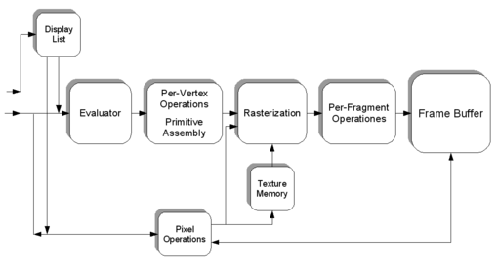

#include <GLUT/glut.h>

**What is GLUT? How is it different from OpenGL?**

Because OpenGL doesn't provide routines for interfacing with a windowing system or input devices, an application must use a variety of other platform-specific routines for this purpose. The result is non-portable code.

GLUT is a library that addresses these issues by providing a platform-independent interface to window management, menus, and input devices in a simple and elegant manner. Using GLUT comes at the price of some flexibility.

Dynamics and Physics :

In order to calculate the trajectory of the spacecraft the Hohmann Transfer principle was used, as well as take into account the main mathematical laws that govern the orbital mechanics and the geometry of the orbits themselves.

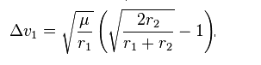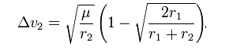

**

• Using data derived from the Near Earth Object Program ( http://neo.jpl.nasa.gov/orbits/ )

Which catalogues the orbits of many asteroids in the asteroid belt in the Solar System, we calculated the aphelion then we calculated the trajectory of the spacecraft must take to arrive at the asteroid’s aphelion position. The aphelion landing point was chosen because at that point the speed of the asteroid is minimal, therefore the difference between the speed of the spacecraft and the asteroid is less and this results in a saving of fuel and thus a reduction of the costs related to the mission.

Considering the close relationship between the total costs related to the mission and the fuel consumption we used the Tsiolkovsky rocket equation, which relates the difference in speed between the spacecraft and the asteroid with the total mass of the spacecraft - launcher , to calculate the amount of fuel necessary to reach the aphelion of the selected asteroid.

Tsiolkovsky rocket equation 